Angle Classification

Right Angle Acute Angle Obtuse Angle
(Amplitude 90º) (Amplitude less than 90º) (Amplitude more than 90º)

Flat Angle Revolution Angle
(Amplitude 180º) (Amplitude 360º)

Triangles Classification

Triangles classification according the angles amplitude:

Right – angle Triangle One of its angles is a right-angle

Acute – angle Triangle All of 3 angles are acute-angles

Obtuse – angle Triangle One of its angles is a obtuse-angle

Triangles classification according the sides measuring:

Scalene triangle Isosceles triangle Equilateral triangle

All of the 3 sides have 2 of the 3 sides have All of the 3 sides have
different measures the same measure the same measure

Triangles Construction

Attention:

Before you start doing any kind of geometry, you most certify yourself if you have all the material you need:

• Well sharpened pencil
• Compass
• Ruler and square
• Protector (instrument for measuring angles)

You should also pay attention that: $\overline{\text{AB}}$ = segment measure

A$B$C = the amplitude of the angle $∠$ ABC

How can we build a triangle knowing the measures of its 3 sides?

Imagine that you were asked to built a scalene triangle, which the sides measures were
4cm, 4,5cm and 3,5cm.

Procedure:
Start by drawing a segment $\left[\text{AB}\right]$ with
3,8cm of measuring

A B
With the steel pointer of the compass on the vertex B, draw a circle arc with 4cm of radius

A B

Now, again with the help of your compass draw another circle arc.
With the steel pointer of the compass on the vertex A, draw a circle arc with 4,5cm of radius.

A B
The point were those 2 circle arcs cross
it’s the 3rd vertex of the triangle
C

A B

How can we build a triangle if we’re given the measure of two of the sides of the triangle and the angle between them?

1st case: When the triangle that we’re asked to build is a right angle triangle
(In this case we’re going to use a ruler and a square to build the triangle)

Imagine that you’re asked to build a right angle triangle with one side measuring 4cm and the other measuring 3cm.

Construction step by step:
Draw a segment $\left[\text{DE}\right]$ Draw $\left[\text{DF}\right]$ $\left[\text{DE}\right]$ Once you have all
4cm long and $\overline{\text{DF}}$= 3cm the 3 vertexes
complete the triangle
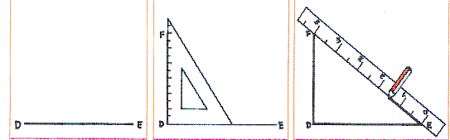

2nd case: When the angle between both of the sides is not a right angle
(In this case we already use the protector)
R
Example: Build a triangle $\left[\text{PQR}\right]$, knowing that: 3 cm
$\overline{\text{PQ}}$= 4cm $\overline{\text{PR}}$= 3cm P Q
$Q\overset{}{P}R=\text{50}º$ 4 cm

Construction step by step:
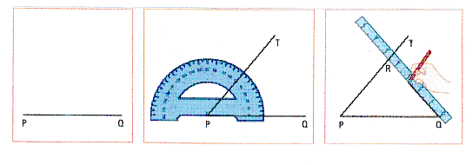
How can we build a triangle if we’re given the measure of one of the sides of the triangle and amplitude of both of its adjacent angles?

Example: Build a triangle $\left[\text{LMN}\right]$, that: N

$M\overset{}{L}N=\text{40}º$$N\overset{}{M}L=\text{60}º$ $\overline{\text{LM}}$= 4cm L M

Construction step by step:

1st : You start by marking a segment 5cm long L M

2nd : Now draw the angles $∠$MLN and $∠$NML according to the picture

The point were those two angles cross it’s the 3rd vertex of the triangle.

